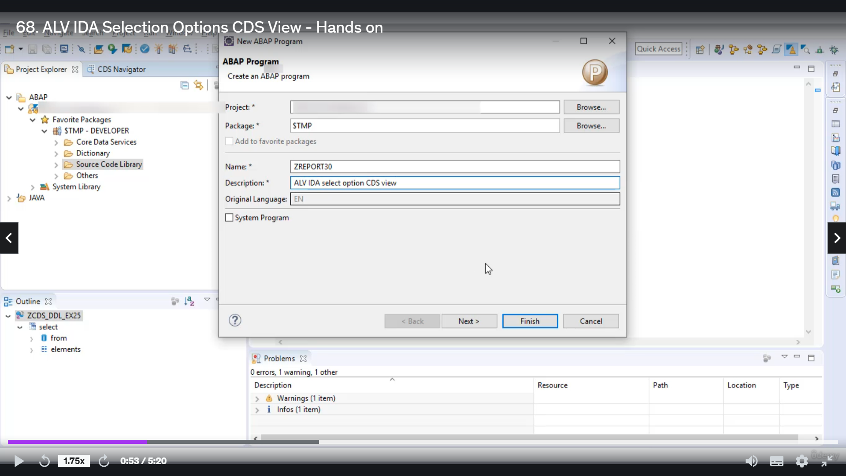

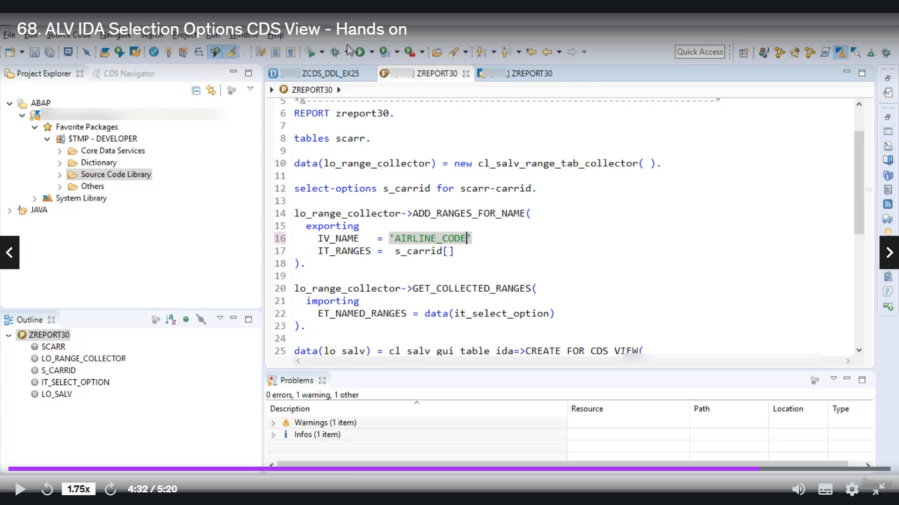

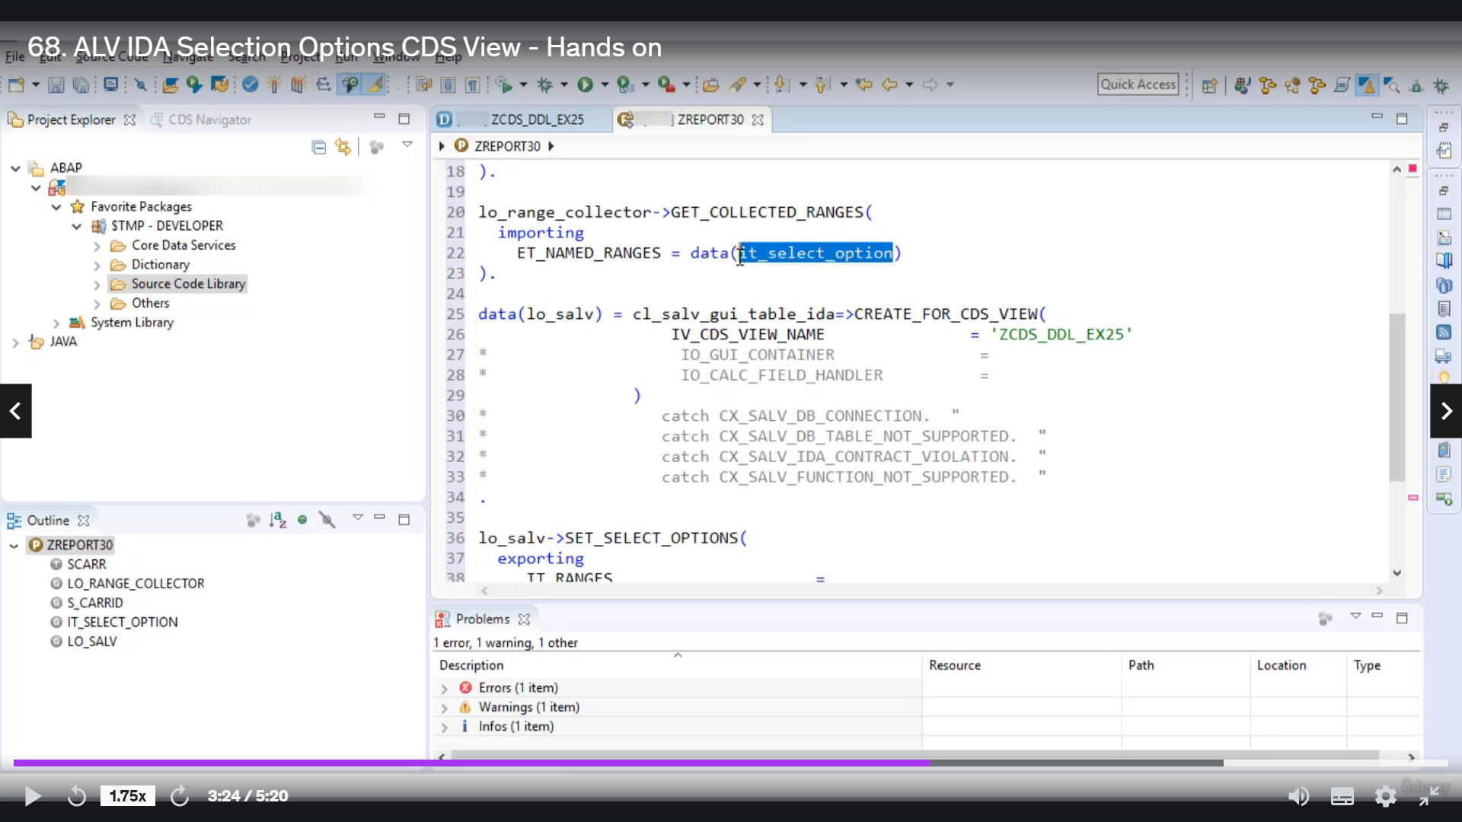

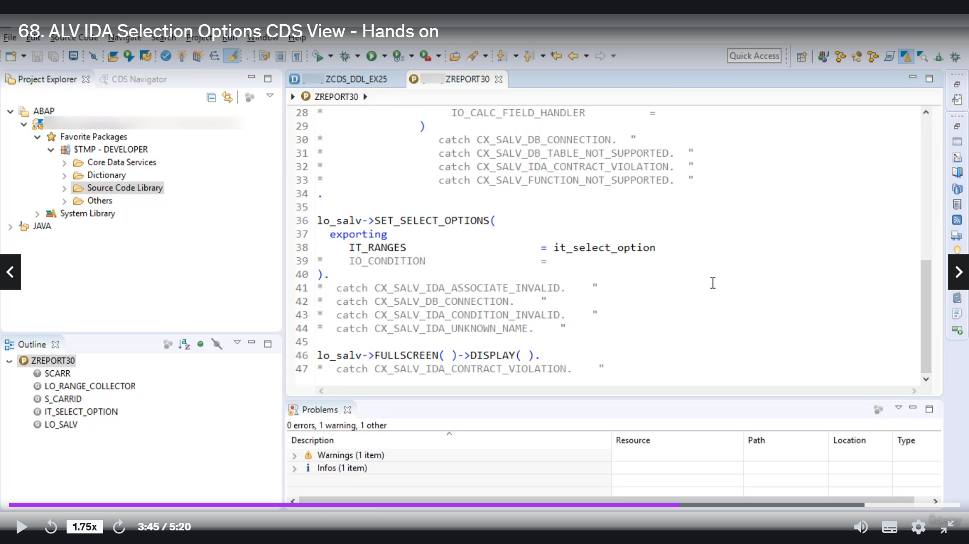

Now, let's see how you can use select option to filter out data in ResultSet above studious view using

Elveden.

So let's start for this example I will use to this which we have already created.

Jake, example 25.

So now let's grapevine about football program.

Let's give it Drudge Report.

Thirty description is a TV idea, select option, seriously, you.

Looks great on object name L'Orange charactor.

Of class SLV, strange deb collector.

Select option is and is carried forward, scared Kennedy.

OK, somehow using Instant's L'Orange collected your call to Method Alperin just for me, then here

you are to specify field karati and derange as is underscored carroty.

Then you have to give a call to me to get collected renge.

And you have to collect the output of this meeting to internal table.

Let's say it option.

Now, let's give a call to Mr..

Korean facility is full of glass A with the tabloidy.

Now, here you have to parse the name of Syria to suggest that we are using Syria's detailed example

to define OK.

Now, your two part range collected in unintelligible, I did select options to Elveden Stuntz using

metal select option.

Now, here you are to pass.

Internal debates, select option.

You have to be called to mentor Fullscreen

and then to me to display.

There is no error, so we cannot do it unless there are no good.

Now, here you can possuelo.

And execute.

OK, so we got your short term.

Silly idea and the name.

So here we have done when we stick.

Since we have given them to free Canadians airline code here, you have to write the airline code.

OK, so now let's activate.

All right.

Rearrange A to a B and execute.

And here we got the output, so now I hope you understood how you can use select option to filter data

and results at all about Petunia's fill in ALVIDA.

That's it for now.

Have a nice day.